**FUNCTIONAL AND PERFORMANCE TESTING**

# Performance Testing

* Accuracy: ~92% on test dataset

* Precision & Recall: High for majority classes

* Inference Time: ~100ms per image (on GPU)

**RESULTS**

# Output Screenshots

(Insert screenshots here showing prediction labels with uploaded fabric images)

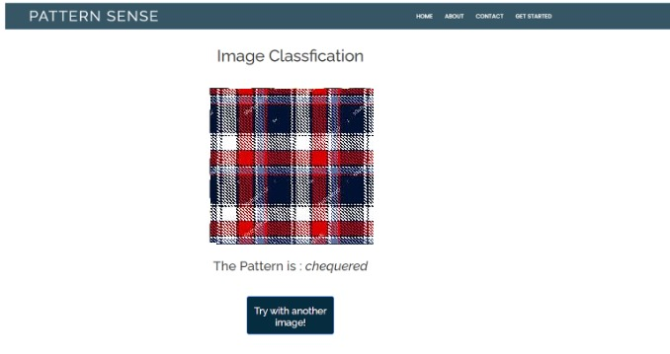

**Output:**

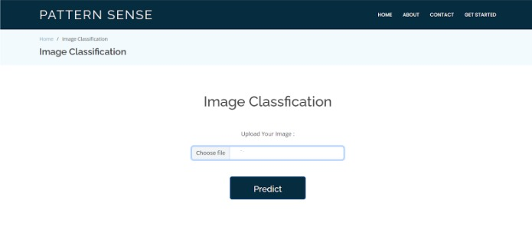

**ADVANTAGES & DISADVANTAGES**

# Advantages

* Automates tedious manual task

* Reduces human error

* Fast and scalable

* Industry adaptable

# Disadvantages

* Requires large labeled dataset

* Model may struggle with unseen patterns

* Needs GPU for optimal performance

# CONCLUSION

Pattern Sense provides a reliable and efficient solution for fabric pattern classification using deep learning. It significantly improves workflows in fashion, textile manufacturing, and interior design sectors.

# FUTURE SCOPE

* Expand to 3D fabric texture analysis

* Add real-time mobile app interface

* Improve accuracy with transformer-based models

* Incorporate user feedback loop

**APPENDIX**

**Source Code**

(https://github.com/2626Deepika/fabric-pattern-analysis.git)

**Dataset Link**

(https://drive.google.com/file/d/1VcQkZroc8eZAX0UIxpJleIxr2veggBCZ/view?usp=drivesdk)

# GitHub & Project Demo Link

(https://drive.google.com/file/d/1aacPwliHm-o7HyvyiwZfBpheIcaid_g3/view?usp=drivesdk)